Professional Programming Practice – Assignment 4
Prekshya Sharma – 11625754

BUG 6 – Notice about age permission should shown
Description: The player is only allowed to play the game if he/she is over 18 years old. If the player is under 18, a notice should be shown and the game cannot be started.

- Replication.
Rule number ten of the game:
In the Main class, after starting the game there is no line of code that mentions the age permission to play the game:
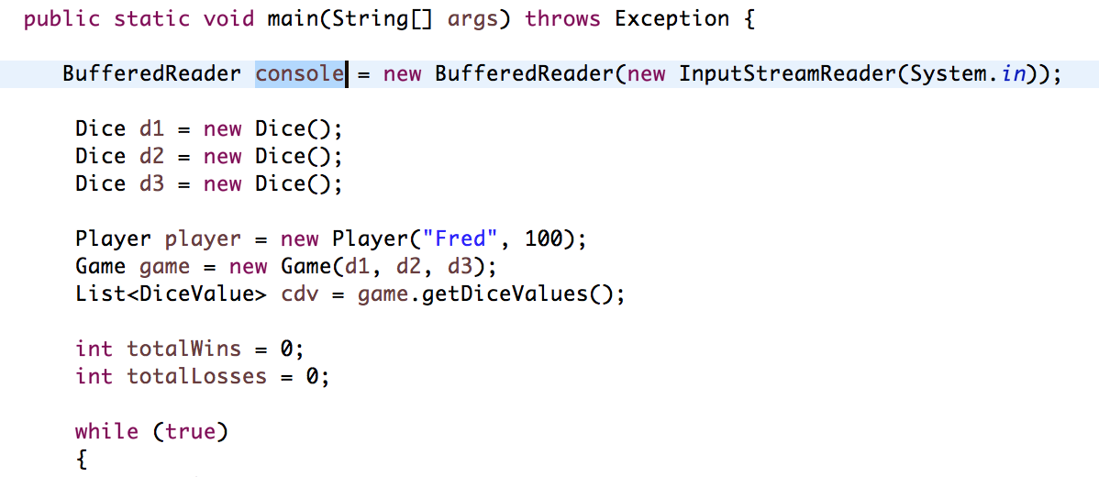
2. Simplification
At start, the program should ask the user to input his age. After checking the age, the program responses with approciate actions.

3. Tracing
Please read the comments to see which actions should be taken at which points:
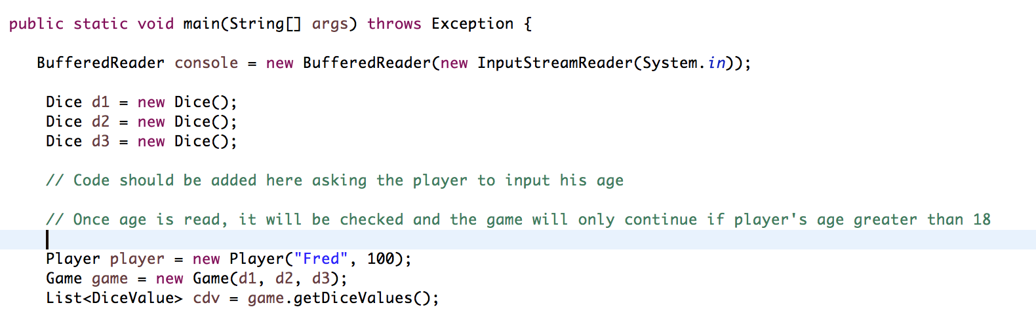
4. Resolution
Code should be added as bellow:
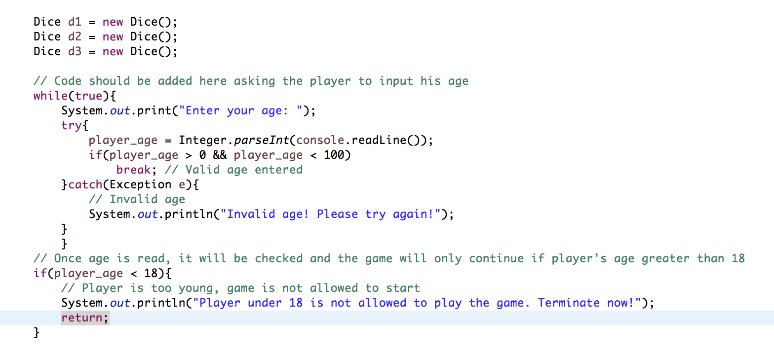
And when the game starts, it asks player to enter his age:
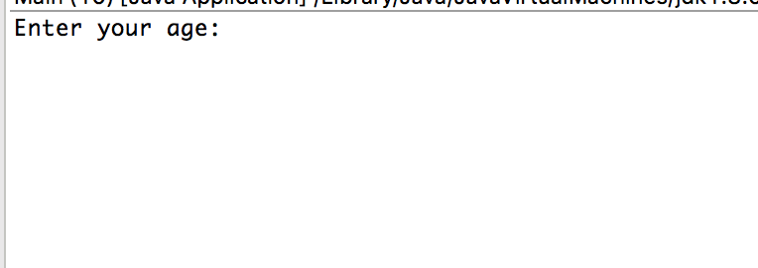
If the player enters a string, it keeps asking again and again:

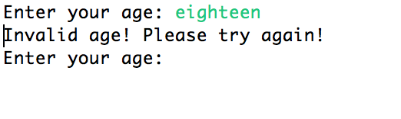
If the player is 18 or older, game allows him to play:

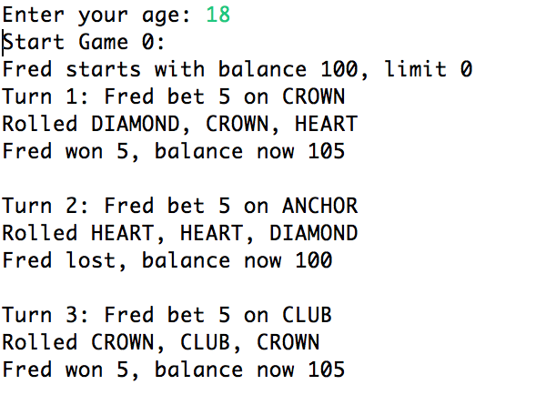

What if the player is younger?
